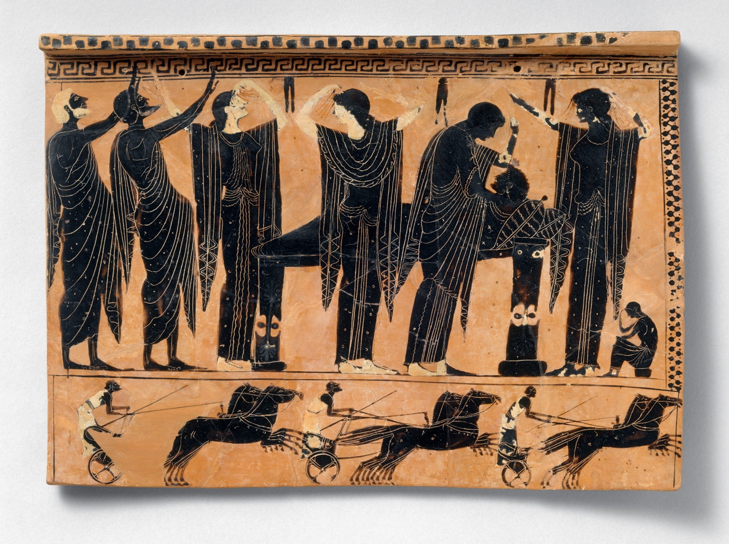Επιστημονική Συνάντηση ΕΠΕΛ, Δ.Π.Θ.-University of Florida, UF

Aspects of Gender in Greek Poetry and Prose
15.5.2026
Σύνδεσμος
https://teams.microsoft.com/meet/3732957736498?p=w4zfQDoxeFIXZTFydr

Πρόγραμμα/Programme

A. Gender and Ancient Life
10.00–10.20 EDT (ελληνική ώρα 17.00–17.20 EEST) Giannadaki, Ifigeneia, Constructing the ethos of the metic in Attic oratory: beyond the gender factor
10.20–10.40 EDT (ελληνική ώρα 17.20-17.40 EEST) Kapparis, Konstantinos, Images of the hetaira in Greek oratory and comedy
BREAK/ΔΙΑΛΕΙΜΜΑ 10.40-11.00 EDT (ελληνική ώρα 17.40-18.00 EEST)
B. Gender and Mythology
11.00-11.20 EDT (ελληνική ώρα 18.00-18.20 EDT) Arabatzis, Stavros, Alcmene and Heracles: Motherhood and divine intervention
11.20-11.40 EDT (ελληνική ώρα 18.20-18.40 EDT) Manakidou, Flora, Argos and Women: Some Thoughts on Myth and History
C. Graeco-Roman Gender
11.40-12.00 EDT (ελληνική ώρα 18.40-19.00 EDT) Rea, Jennifer Αnn, Daughter, Mother, Visionary, Advocate: Perpetua's Productive Dreams in the Passio
12.00–12.30 (ελληνική ώρα 19.00-19.30) DISCUSSION /ΣΥΖΗΤΗΣΗ

